Group contract

Group number: L07G01
Name: Karin Gao
GitHub link: https://github.sydney.edu.au/kgao2072/L07G01.git
I agree to:
- Abide by the terms of this contract in relation to the group assessment for DATA2002/2902.
- Store all my contributions to the assessment in the GitHub repository.
- Keep an accurate record of my contribution to the assessment. A copy of this may be requested by the coordinator.
- Work cooperatively, treat each other with respect, act honestly and ethically and not engage in any activities that could be perceived as bullying or harassment, as detailed in the Student Charter
- Communicate via discussions on Instagram group chat to provide updates on specific tasks. We will also do a weekly call via Zoom to come together as a team and do a more specific progress check on the project overall.
- Check Instagram daily and check in with GitHub at least once a week and more regularly as we get closer to the deadline. If something on GitHub is urgent, it will be messaged in Instagram and the relevant people notified using their @username tag.
- Attend labs in the weeks before the tasks are due and do a Zoom meeting the day before the lab presentation to run through it to ensure a smooth run-through on the day.
I understand that:
- My agreement to these terms is indicated through the act of submitting this in Canvas.
- If I fail to meet my obligations as detailed in this group contract, then I have failed to meet the assessment requirements for DATA2002/2902 and may be awarded a mark of zero for some or all of the project components.

Exploratory data analysis

Data set: Palmer penguins
Dependent variable: Body mass

library(tidyverse)
theme_set(theme_bw())
data("penguins", package = "palmerpenguins")
Looking at the pattern of missing data:
visdat::vis_miss(penguins) + coord_flip() + theme(legend.position = "none")
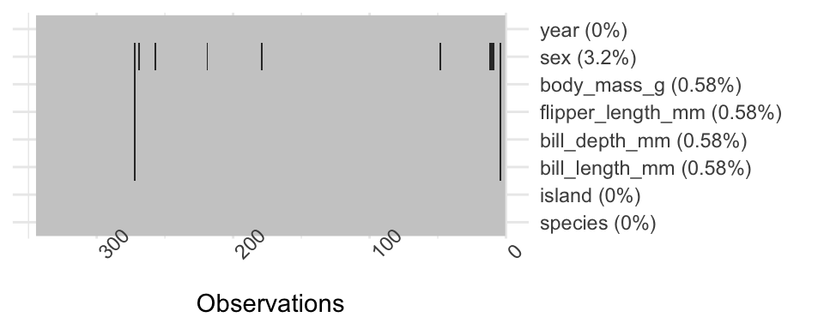
Descriptive statistics:
table1::table1(~ bill_length_mm + bill_depth_mm + flipper_length_mm + body_mass_g + island | species + sex, data = penguins, overall = FALSE)
 | Adelie |  |  | Chinstrap |  | Gentoo
 |  | female  (N=73) | male  (N=73) | female  (N=34) | male  (N=34) | female  (N=58) | male  (N=61)
bill_length_mm
Mean (SD) |  | 37.3 (2.03) | 40.4 (2.28) | 46.6 (3.11) | 51.1 (1.56) | 45.6 (2.05) | 49.5 (2.72)
Median [Min, Max] |  | 37.0 [32.1, 42.2] | 40.6 [34.6, 46.0] | 46.3 [40.9, 58.0] | 51.0 [48.5, 55.8] | 45.5 [40.9, 50.5] | 49.5 [44.4, 59.6]
bill_depth_mm
Mean (SD) |  | 17.6 (0.943) | 19.1 (1.02) | 17.6 (0.781) | 19.3 (0.761) | 14.2 (0.540) | 15.7 (0.741)
Median [Min, Max] |  | 17.6 [15.5, 20.7] | 18.9 [17.0, 21.5] | 17.7 [16.4, 19.4] | 19.3 [17.5, 20.8] | 14.3 [13.1, 15.5] | 15.7 [14.1, 17.3]
flipper_length_mm
Mean (SD) |  | 188 (5.60) | 192 (6.60) | 192 (5.75) | 200 (5.98) | 213 (3.90) | 222 (5.67)
Median [Min, Max] |  | 188 [172, 202] | 193 [178, 210] | 192 [178, 202] | 201 [187, 212] | 212 [203, 222] | 221 [208, 231]
body_mass_g
Mean (SD) |  | 3370 (269) | 4040 (347) | 3530 (285) | 3940 (362) | 4680 (282) | 5480 (313)
Median [Min, Max] |  | 3400 [2850, 3900] | 4000 [3330, 4780] | 3550 [2700, 4150] | 3950 [3250, 4800] | 4700 [3950, 5200] | 5500 [4750, 6300]
island
Biscoe |  | 22 (30.1%) | 22 (30.1%) | 0 (0%) | 0 (0%) | 58 (100%) | 61 (100%)
Dream |  | 27 (37.0%) | 28 (38.4%) | 34 (100%) | 34 (100%) | 0 (0%) | 0 (0%)
Torgersen |  | 24 (32.9%) | 23 (31.5%) | 0 (0%) | 0 (0%) | 0 (0%) | 0 (0%)
Initial visualisations:
penguins |> drop_na() |> ggplot() + aes(y = sex, x = body_mass_g) +
geom_boxplot() + facet_grid( species ~ .)
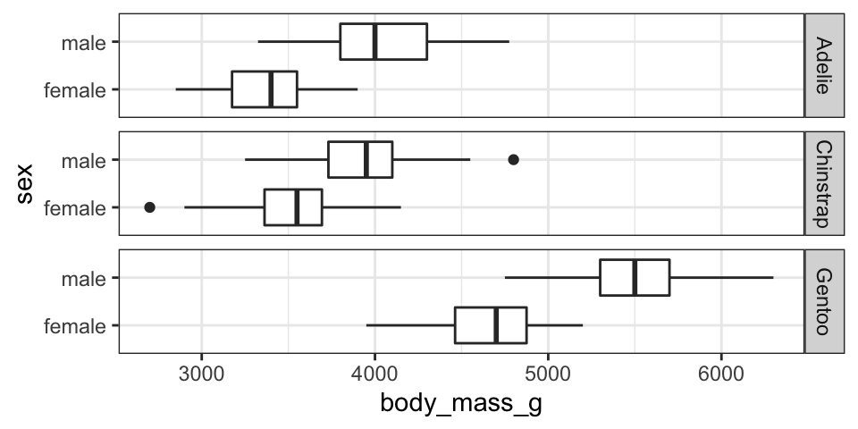
penguins |> select(-island, - year) |>
pivot_longer(cols = c(bill_length_mm, bill_depth_mm, flipper_length_mm),
names_to = "variable", values_to = "values") |>
drop_na() |> ggplot() +
aes(x = values, y = body_mass_g, colour = sex) +
geom_point(alpha = 0.3) +
facet_grid(species ~ variable, scales = "free_x") +
scale_colour_brewer(palette = "Set1") +
geom_smooth(method = "lm", se = FALSE) +
theme(legend.position = "top")
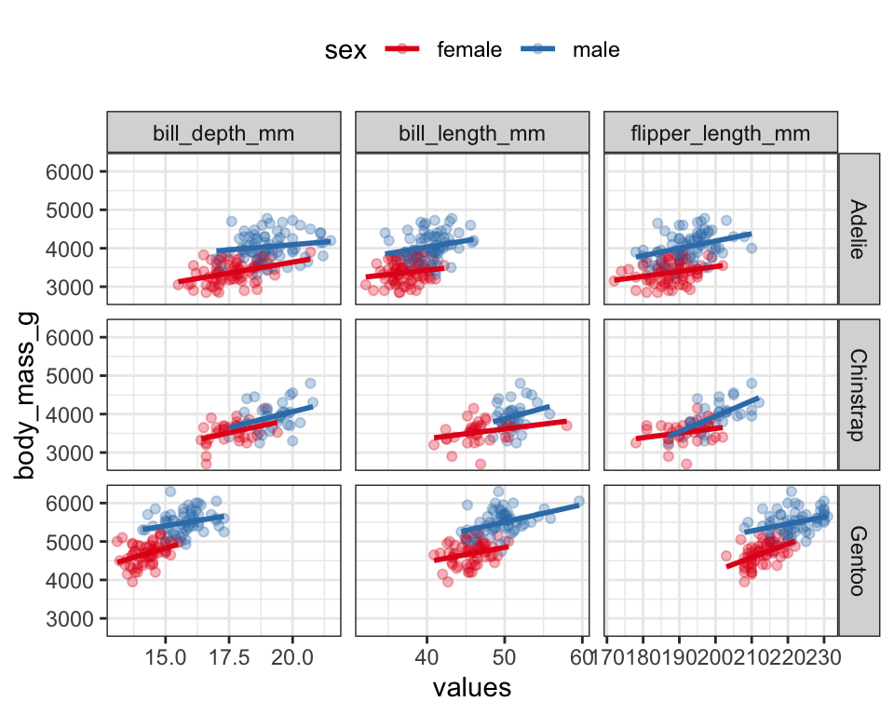
Summary: From my initial EDA it looks like species and sex are both important factors for predicting body mass. There also appears to be relationships between body mass and the bill and flipper measurements.

Note: your EDA doesn’t necessarily need to include the R code, I included mine just to show how I generated the outputs. I still used a .qmd file but then copied the output into this Word document. If you’re interested, the start of the .qmd file was:

---
title: 'Project EDA'
format:
docx:
fig-format: retina
---

```{r, message=FALSE}
library(tidyverse)
theme_set(theme_bw())
data("penguins", package = "palmerpenguins")
```

